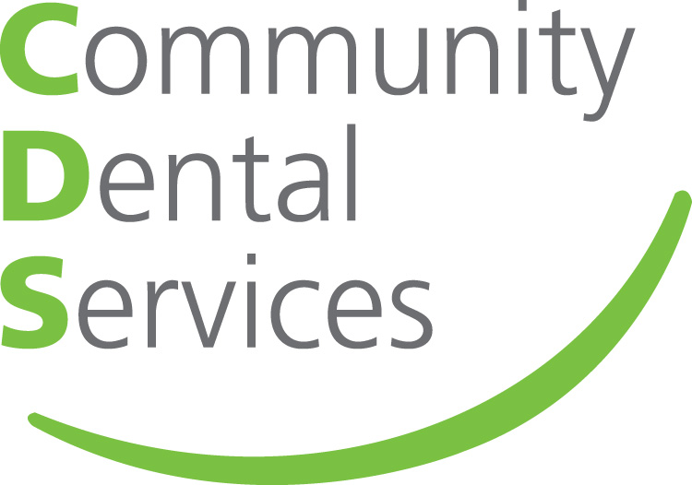
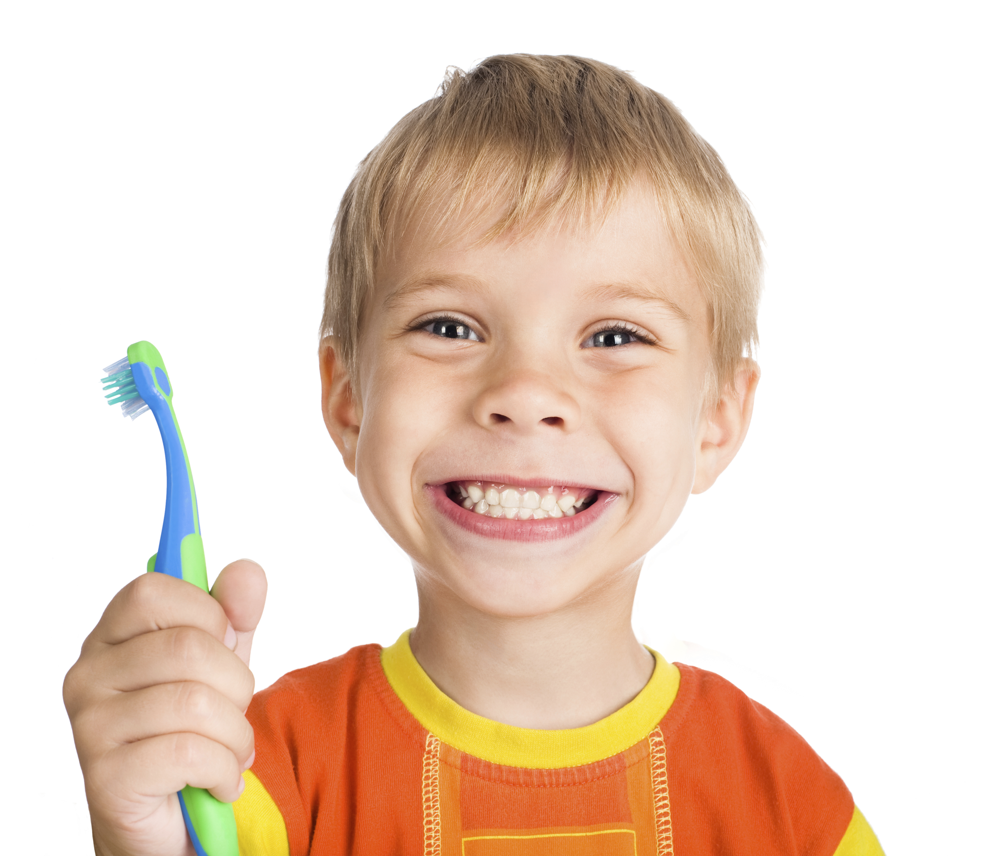

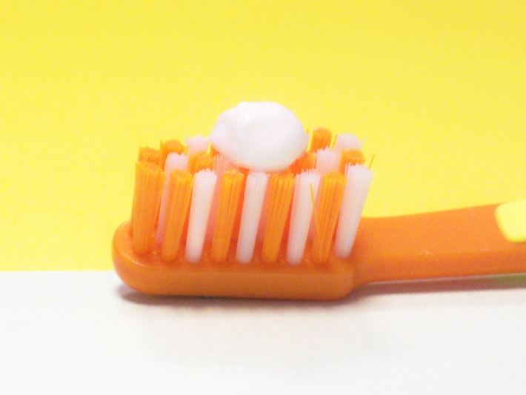
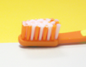
12 Top tips for teeth
Brushing
- Brush before bedtime and one other time during the day
- Use a fluoride toothpaste containing at least 1000 ppm (parts per million)
- Just a smear on the brush for under 3s
- Pea sized amount for over 3s
- Spit – don’t rinse when finished
- Supervise under 8s when brushing
- Children should be taken to the dentist for regular visits

Between meal snacks
- Avoid sugary and acidic food / drinks between meals and an hour before bedtime
- Honey, smoothies, fruit juice and dried fruit are not tooth-friendly snacks
- Milk is a tooth friendly drink during the day, water is tooth friendly at any time
- From 6 months onwards encourage the use of open top cups - discourage bottle use after the age of one year
- Remember to ask for sugar-free medicines whenever possible
smear
pea sized
For more information, visit www.communitydentalservices.co.uk or phone 0116 243 6460
Produced by the Oral Health Promotion Team, Community Dental Services CIC©.

If you need help finding a NHS dentist please telephone:
NHS Helpline: 111
or visit their website: www.nhs.uk
For more information, visit www.communitydentalservices.co.uk
Produced by the Oral Health Improvement Team, Community Dental Services CIC©.

