Registered Charity No. 1028702

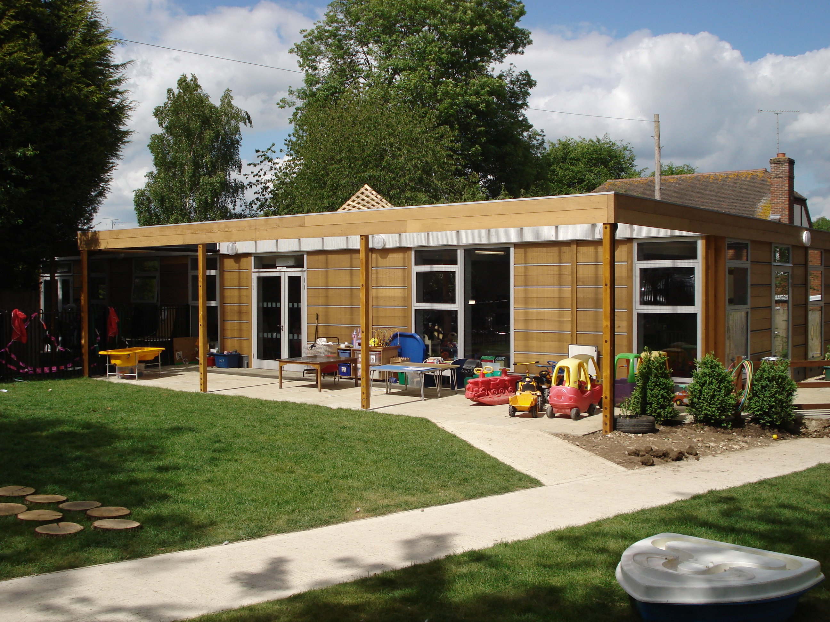

Prospectus

Our Aims

Our Pre-School is based in the grounds of Sonning Common Primary School, in its own self-contained premises, with access to some of the school facilities, such as the playing fields. We have an extensive, well-equipped garden which we use all year round. We also make use of the local library attached to the school.

A parent management committee runs the group.

We provide an excellent educational play environment where children feel happy, calm and secure. The classroom is friendly, bright and cheerful with the children’s artwork proudly displayed on the walls. It is our aim to maintain a safe, healthy and nurturing environment where the developmental needs of children are met. We work in close partnership with parents to ensure consistency of care, sharing information about their child’s development.

It is our ethos that we provide affordable childcare and to be accessible to as many people as possible. We therefore try to keep our prices down as much as we can, while employing good-quality staff and providing excellent resources.

Our latest Ofsted Inspection gave us an overall grading of GOOD. This report can be found on the Ofsted website https://files.ofsted.gov.uk/v1/file/50239392

Quality Improvement

“Research shows that high quality experiences in the early years, including a good home learning environment, have a significant positive impact on children’s social, emotional and cognitive development and, therefore, their progress at school and into adult life.” – Practice Guidance for the Early Years Foundation Stage, 2008, DCSF.

It is important to Sonning Common Pre-School that we continually self-assess and look at ways of improving the quality of learning, development and care we offer. We do this by sending all of our staff on regular training courses, consult parents yearly by way of questionnaires and working with other professionals.

Pre-School Hours
Morning session Afternoon session
Monday to Friday 9.00am – 12.00pm 12.00pm – 3.00pm
Early drop off 8:30am charged at £5
After school club 3-4pm £8 per hour
Lunch Club 12-1pm charged at the hourly rate (see below) not inc lunch
Fees from April 2024

2-3 Year Olds £8.87 per hour (£26.61 per session/£53.22 all day)
3-4 Year Olds £8.50 per hour (£25.50 per session/£51.00 all day)

In order to ensure that the Pre-School runs smoothly, and to help meet our running costs, we request a voluntary contribution of £25.00 per child per ‘big’ term. This will be added to your invoice.

Fees continue to be payable if a child is absent for a short time – for example sickness or holiday. In cases of prolonged absence, parents should consult the committee about fee payment; however, in general we do not refund fees.

Each child’s attendance at the group is conditional upon continued payment of any fees and of payment by the Local Education Authority (LEA) funding.

Admissions and Additional Sessions

The Pre-School will admit children as soon as possible, if sessions are available, after they have turned 2 years old.

If your child is currently on our waiting list our Registrar will contact you nearer the time to discuss when your child can start Pre-School and which sessions you would like. We will always attempt to accommodate your requests but cannot guarantee that the sessions you would like will be available at the time your child starts Pre-School due to the number of children attending.

We have an admissions policy for more information about how we deal with admissions.
Please be aware that our morning sessions are extremely popular and the uptake for these sessions is very high and we cannot always fulfill requests. Ad-hoc sessions (if available) can be booked at the cost of the session.

Funding

The term after your child has turned 3, they are entitled to 15 hours funding per week payable by Oxfordshire County Council. (30 hours for working parents – We are able to offer 18 hours if you are entitled to these additional hours) The funding forms to claim this entitlement will be sent to you by our Registrar on a termly basis.

In September 2017 the government increased the free early education entitlement for working parents of 3 & 4 year olds. Those that meet the eligibility criteria will be entitled to a total of 30 hours per week. At Sonning Common Pre-School we are able to offer 18 hours extended funding for those parents who are eligible. For more information please visit https://www.childcarechoices.gov.uk/

If your child is aged between 2 and 3 yrs, you may be entitled to help with funding. Please contact your local authority to see if you meet their criteria.

Policies

All our Policies are designed to offer the best possible experience for the children and families in the group. Our policies are reviewed on a regular basis and suggestions from parents are always welcome.

Our policies are available to view at any time and there is a list of our policies at the back of this brochure.

Early Years Foundation Stage Framework

At Sonning Common Pre-School we recognise the importance of play, and we use this as the main tool for children’s learning. There is a balance of child-initiated activities and adult-directed activities which are developmentally appropriate. We make use of the outdoors as well as indoors, with free-flow in and out, throughout the session.

Feedback is given to you about your child’s progress by way of written reports once a year and parents are welcome to look at their child’s Learning Journey and talk to their key person anytime.

Key Person System

Our Key Person System enables us to provide activities tailored to the needs of each individual child. Each member of staff has particular responsibility for just a few children. Each child in the group has one special adult to relate to, which can make settling into the group much easier. The Key Person maintains links with the child’s home setting, including initial home visits and working with parents through shared record-keeping to ensure that all children are supported to their full potential. Your child will also have a ‘Buddy Key Person’ who will be your child’s main point of contact should your child’s Key Person be away from Pre-School for any reason.

Activities

We offer an array of activities to enhance the learning and development of each individual child. These include: cooking, gardening, arts and crafts, play-doh, role-play, messy activities, sand and water play, ICT, as well as a huge range of toys, games, puzzles and books for children to choose from.

Outdoors we are pleased to be able to offer the children a forest school environment which the children visit in all seasons and weather. We also have a covered area, where we bring the classroom outdoors, offering a range of activities. We also have ‘wheeled’ toys, playhouse, vegetable garden and sports equipment. All of our resources are checked for breakages and cleaned every term, and replenished regularly to ensure safety and variety.

Snack Cafe

During the session we have a ‘Snack Cafe’ which is open for about an hour. There is a choice of three or four items – one carbohydrate, plus fruit and/or vegetables. We encourage children to be independent by pouring their own drink, buttering toast, cutting up fruit, etc. Snack cafe is supervised by a member of staff and is a very sociable time for the children.
Examples of snack provided: Toast, crumpet, fresh and dried fruits, tomatoes, cheese, carrots.

Hot Lunches

We are able to offer hot school lunches, provided by Kite’s Kitchen, who provide lunches to Sonning Common Primary School. Hot lunches are at an additional cost of £2.50, and need to be ordered in advanced. We can also accomodate any last requests for hot meals, before 9.30 am on the day required. The lunches are served at Pre-school for children who stay all day, or who come to our afternoon sessions. Menus are available at the start of every term.

Forest Camp
Vision Statement
At Sonning Common Pre-Schools forest Camp, our aim is to provide children with regular visits to a natural environment during all seasons and weathers. Children will be able to take control of their own learning and play and will be supported in risky play as staff understand that children will become resilient and confident in their own capabilities if they are allowed to test their ideas and learn from their mistakes.
Staff understand each child is an individual with their own interests, ideas and ways of learning. Staff will provide children with the support and resources they need to test their ideas and support their learning in child led holistic play.

Forest Camp Sessions
Each session will start around the fire circle or under the shelter in bad weather, children will be encouraged to consider and discuss the 3 rules of Forest school:

- Look after each other
- Look after the forest
- Look after ourselves

This will lead into the children walking around the site and being encouraged and supported to risk assess the site and resources themselves.
Children will then be free to play and learn as they wish with support and guidance from adults on site.
Children will then be called back to the fire circle (using an owl call) for a group discussion to reflect on what they did using the forest thoughts basket as a prompt when needed.
Children will be allowed to take supported risks and learn from their mistakes.

Forest Camp Ratios

Forest school sessions will be run by a level 3 qualified forest school leader when using tools or fire otherwise sessions can be run by a level 2 or above qualified forest school leader.

Forest Camp Principles

We adhere to the Forest School Association principles we will abide by the following requirements:

- Our aim is to provide at least one weekly session being sure to keep an up to date register so that each child gets an equal opportunity to take part in a forest camp sesson.

- Staff will do daily risk assessments as well as seasonal and yearly risk assessments, risk benefit assessements will also be carried out to highlight the importance of risky play.

- Children will be provided with an area separate to the main Pre-School which is kept as natural as possible. On site resources will be a variety of loose parts which will be made from natural materials whenever possible to inspire play and learning.

- Children will be supported in risky play and all sessions will be child led

- Staff will endeavour to extend play where possible to allow the childrens play to become as holistic as possible

Play Policy

Here at Sonning Common Pre-School forest Camp, we understand that child led play is massively important to all areas of development and allows children to take control of their own education!
Each child is completely unique so this is why child led play/learning is so important as it allows each child to learn through their own interests, ideas and mistakes in a way that is interesting to each child as an individual.
At forest Camp we promote risky play which encourages children to assess risk themselves, children are then able to test their ideas, make their own mistakes, learn from them and move on, enabling the children to become resilient and confident individuals.

We are going to get muddy, wet, and we’re probably going to get a few scratches, bumps and bruises along the way, but in the end we hope the children will be resilient, imaginative, confident, compassionate and above all else Happy!

Special Needs

Every child in our Pre-School is special and is able to progress at his/her own rate in all areas of development - whether s/he has a disability or learning difficulty. Staff are trained in areas of special needs and positive behaviour. We also recognise that some children have English as an additional language, and try and support this where possible.

If you would like to discuss the group’s ability to meet your own child’s individual needs, please talk to the Pre-School Manager or your child’s key person.

Our full Special Educational Needs Policy is availble at Pre-School.

Our Staff

We are proud of our high ratio of adults to children in our group. We work on the ratio of 1 adult to every 4 children under 3 years and 1 adult to every 8 children over 3 years. We have between 5-6 members of staff for each session. This ensures individual attention to the needs and development of each child. We are dedicated to ensuring that our staff are qualified and keep training up-to-date by attending short courses. All of our staff are 12 hr peadriatric First Aid (PFA) trained. All staff and committee are DBS checked to work with children.

Involving Parents

We actively encourage parents to be as involved in Pre-School as they wish. The parent information board outside is a good source of information. We welcome any parent who wants to join in one of our sessions, assist with fundraising or to join the committee.

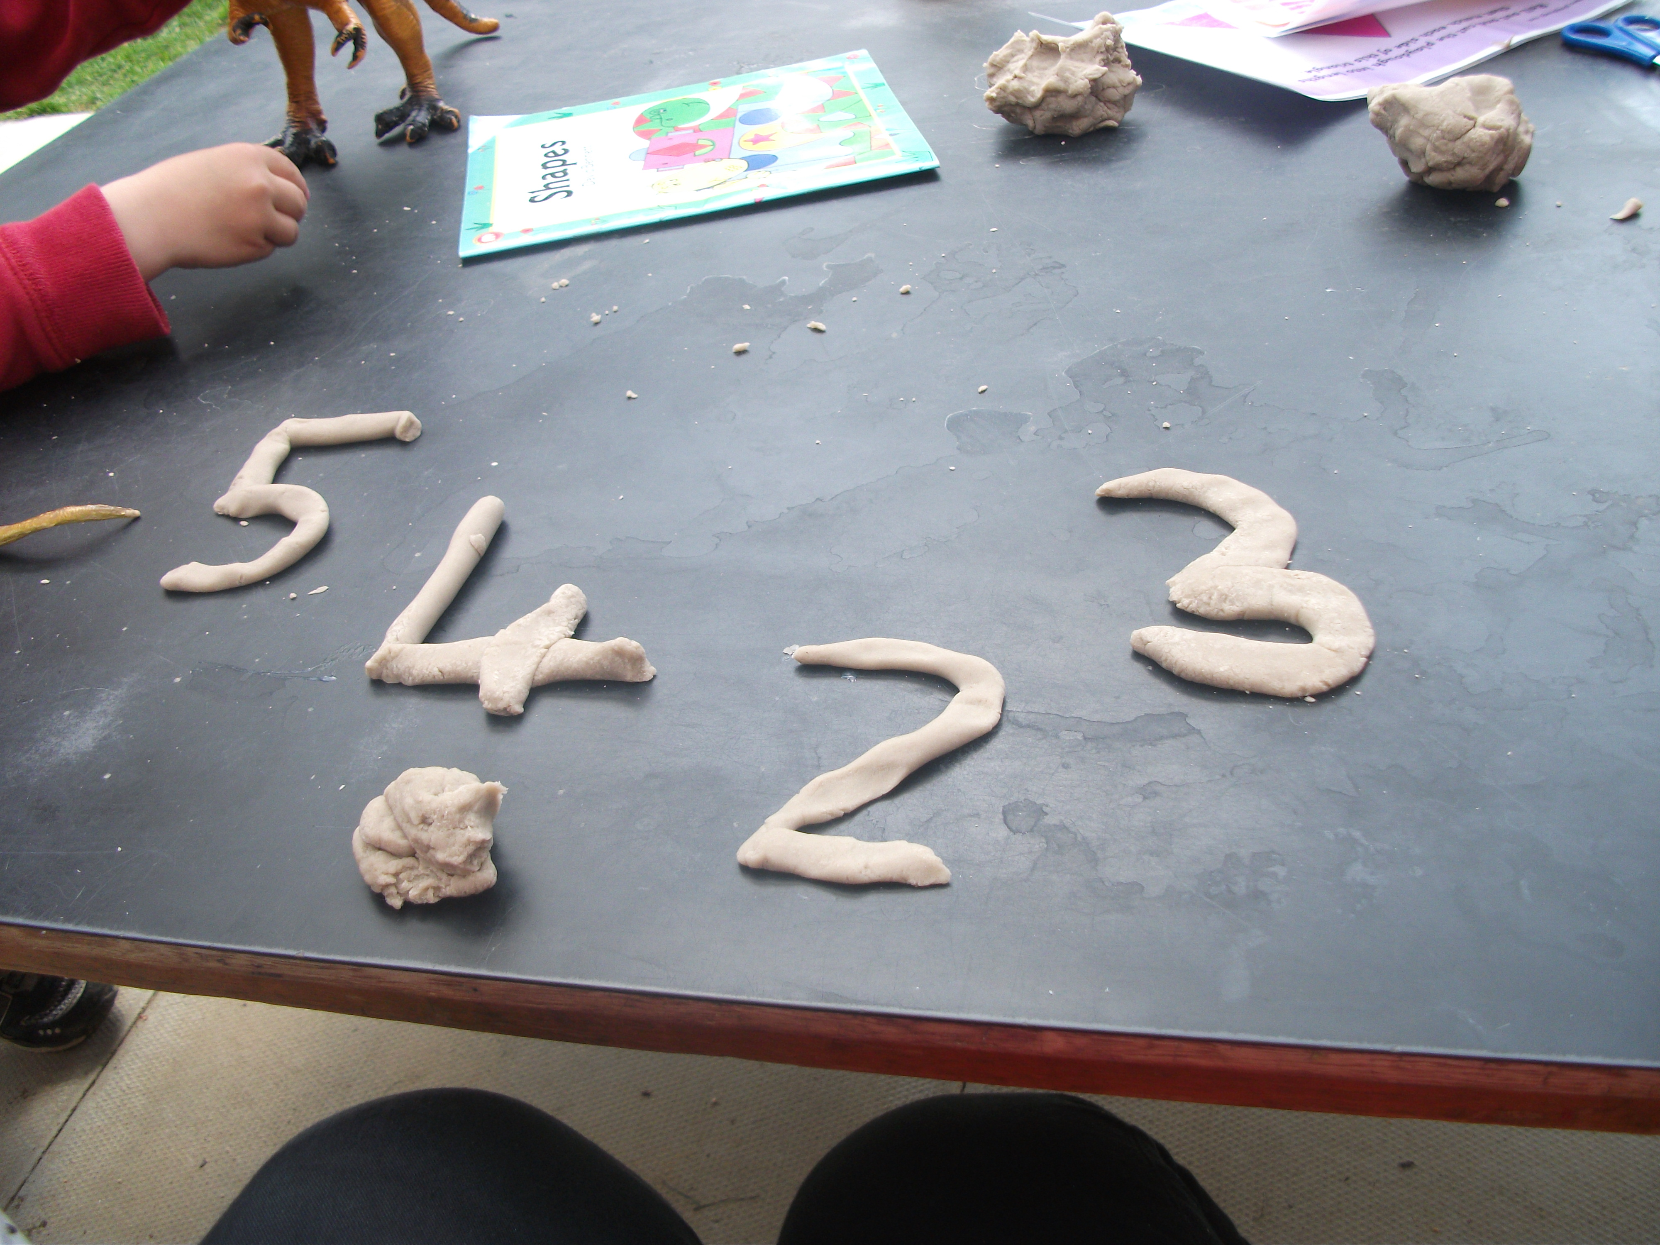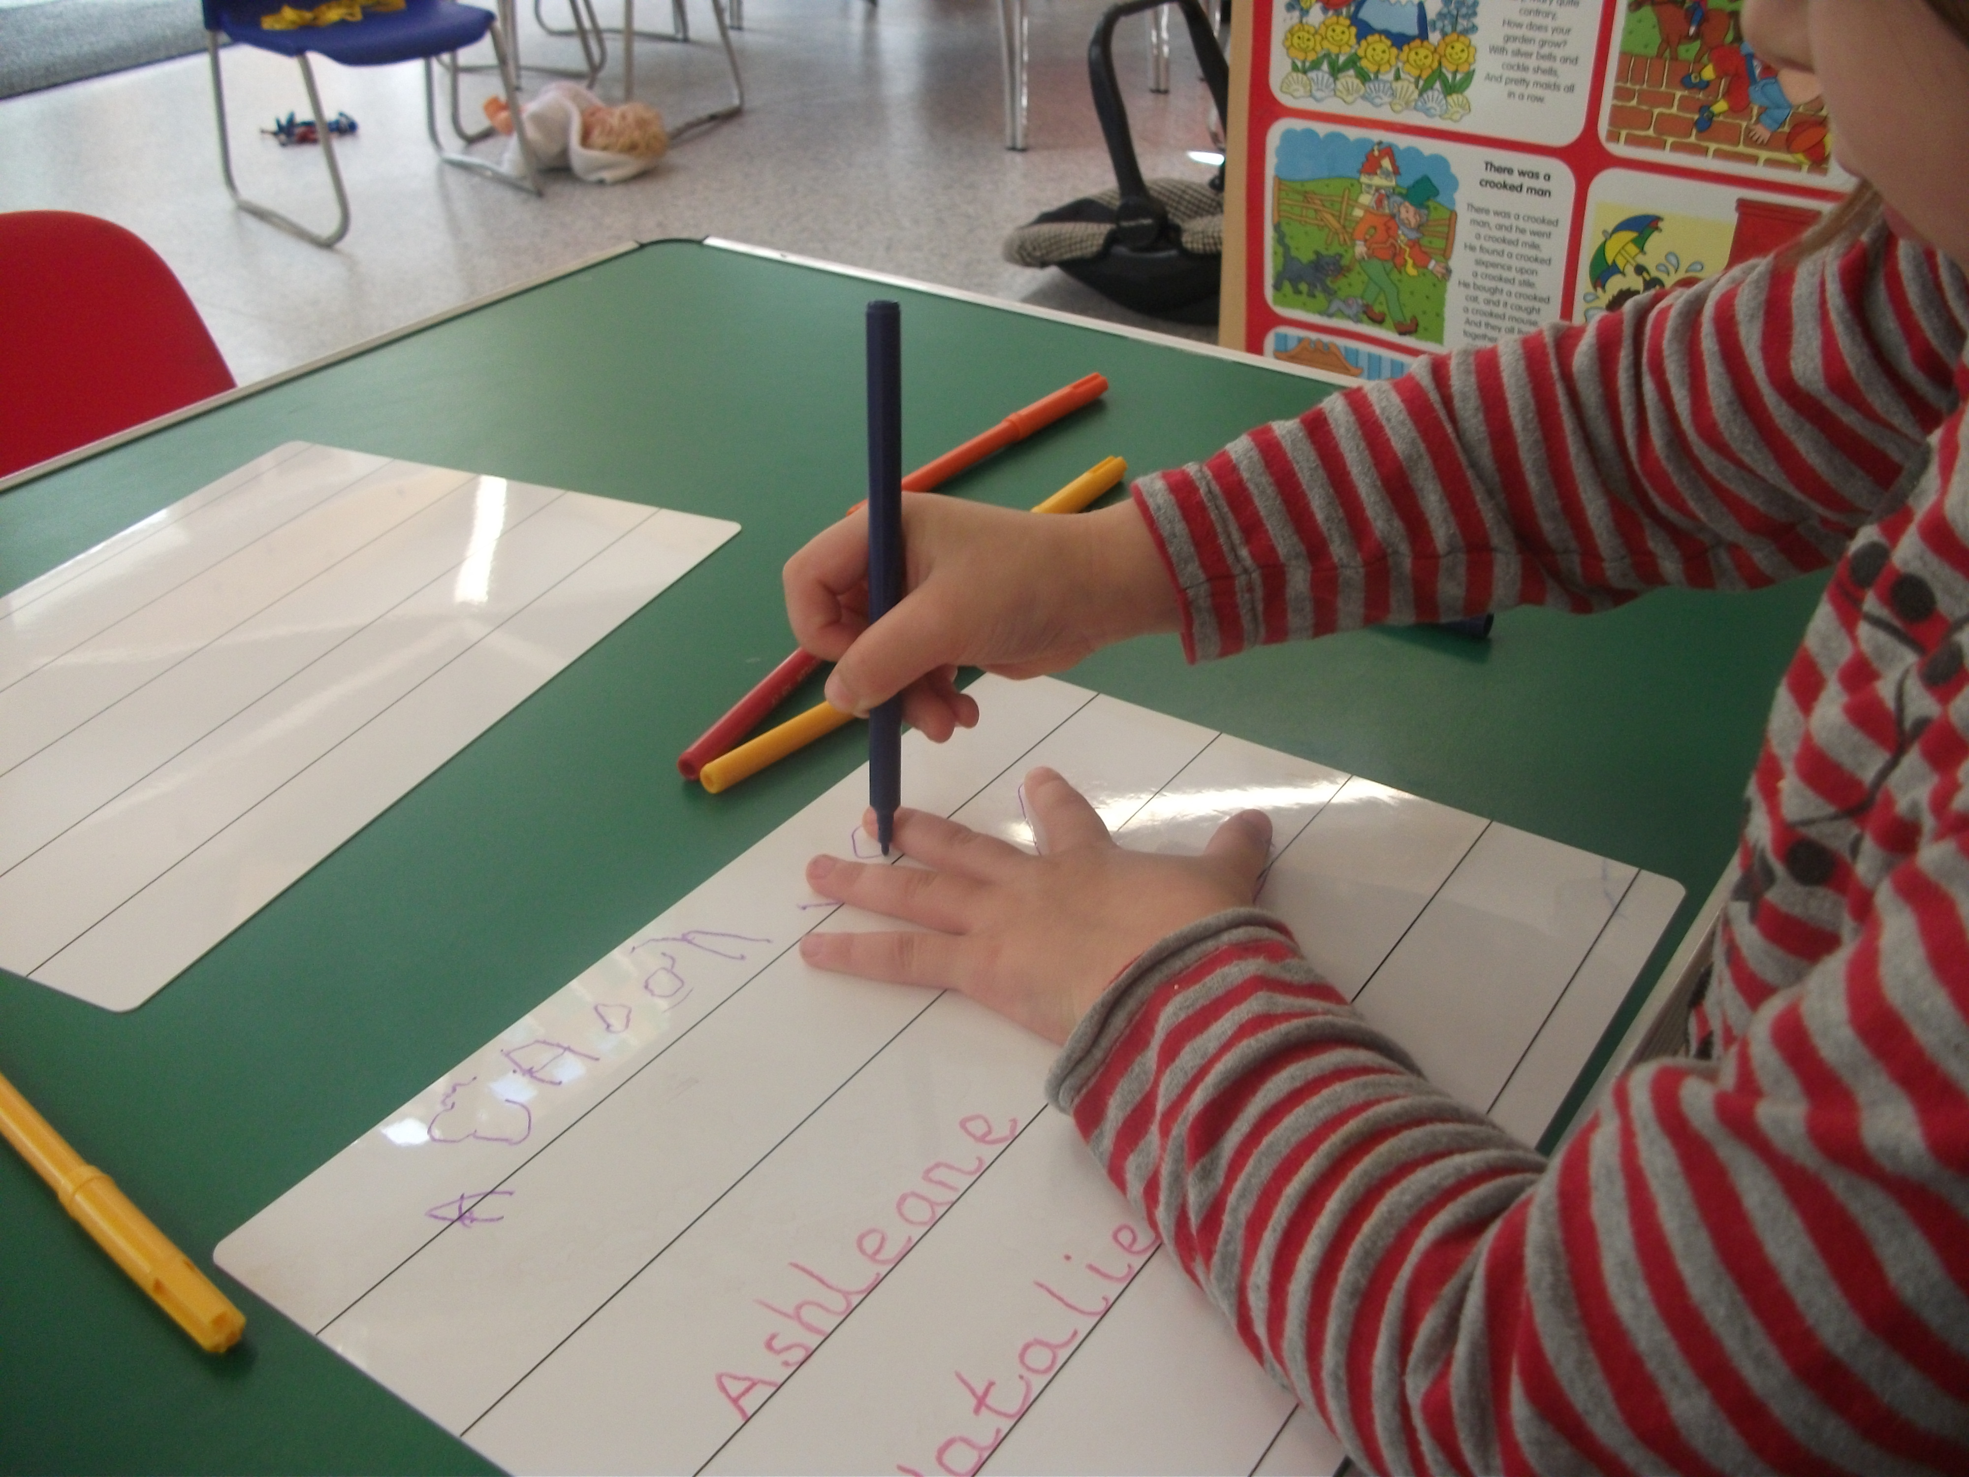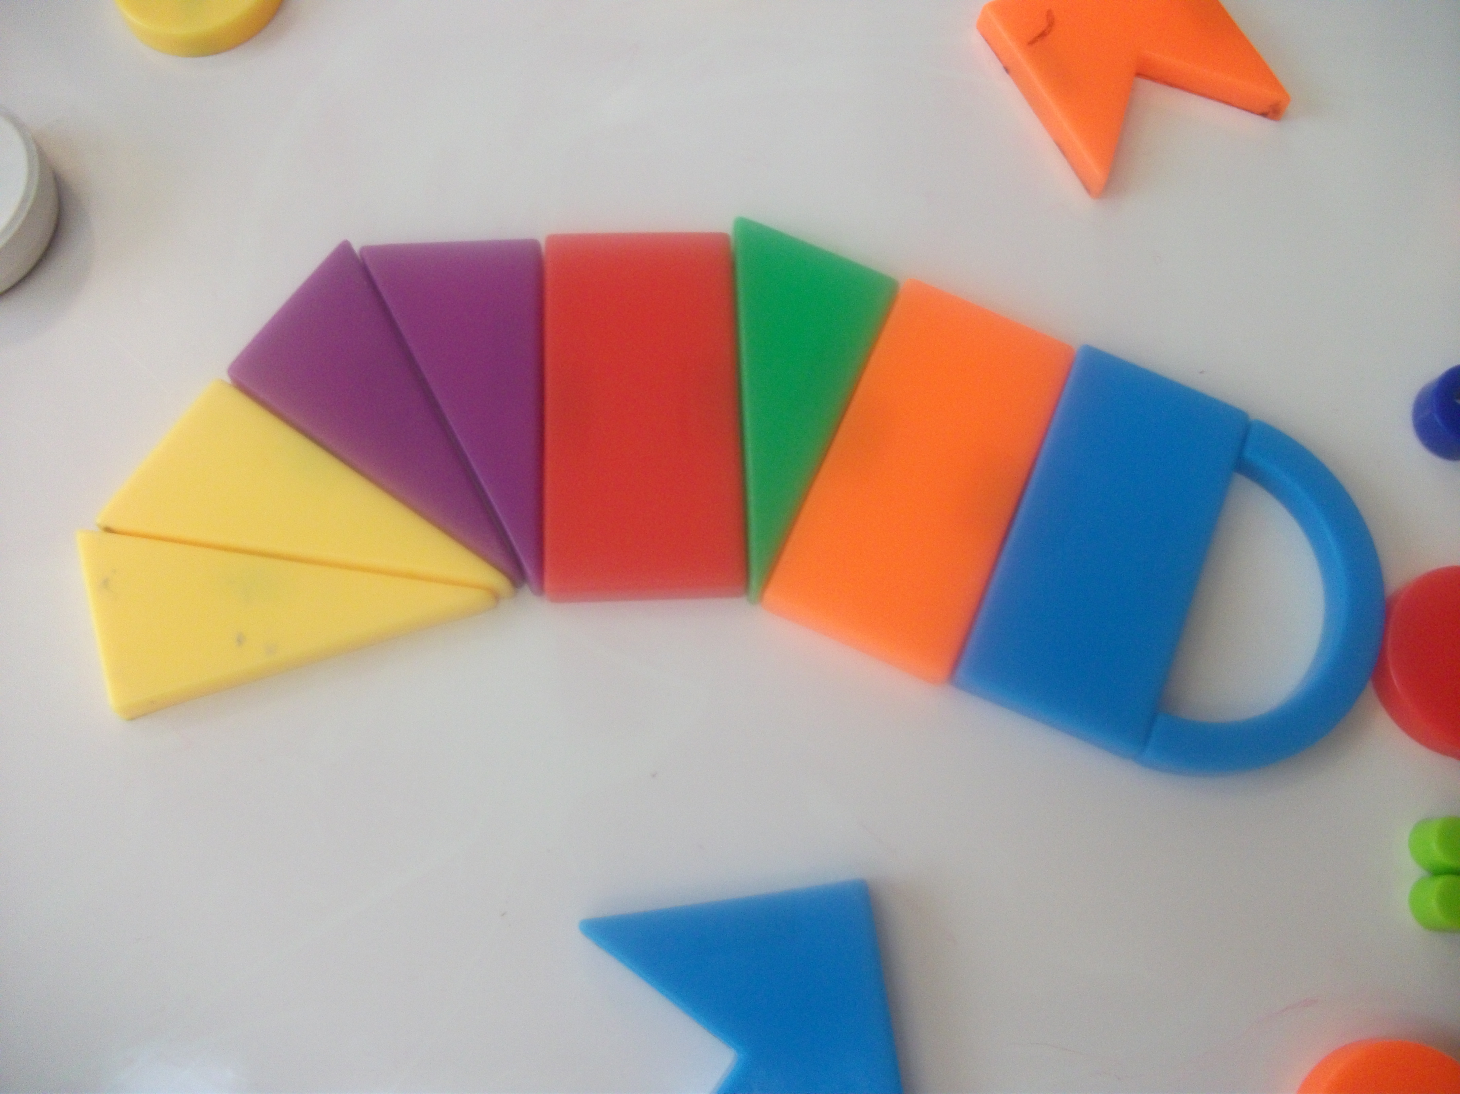

Management Committee

Our Pre-School is run by an elected parent management committee, which, in conjunction with the Manager of the Pre-School ensure that major decision-making is in the hands of the parents who use the group. The committee members are responsible for reviewing both policies and practice and help in the employment and appraisals of members of staff.

Our Annual General Meeting, at which the committee for the following year is elected, is held in June and parents are informed in good time so they are given the opportunity to attend. A list of Committee Members, contact details and photos are on the notice board.

Pre-School Learning Alliance (PLA)

The Pre-School Learning Alliance is a leading educational charity specialising in the early years. We are a member of the PLA and actively follow their values of helping children to succeed by creating childcare that families need, actively promoting parental involvement and inclusive practice.

Famly

We use the Famly App which allows parents to see photos and videos of your child’s day in the newsfeed, receive invoices, accident forms and messages. Parents can also use the app to report sick and holiday days and communicate with other Pre-School parents.

Starting at Pre-School

A child who is unhappy will not be able to play or learn, so it is important for us to work together to help your child feel confident and secure. This takes longer for some children than others and you should not feel worried if your child takes a while to settle.

An initial home visit before your child’s first session is arranged making this ideal opportunity t discuss your child’s needs as well as getting to know your child. It covers early skills and whether your child will need help, for example putting on their coat, washing their hands etc. We also find out about your child’s likes and dislikes, etc, so that we can steer them towards activities we know they will enjoy.

At the start and end of the session we ask that parents wait in the reception area until the door is open. When entering please help your child to find his/her name in their drawer and a peg for their belongings. Shoes should be changed, especially in wet weather to help keep the classroom clean. Please feel free to enter the classroom with your child, talk to staff and stay as long as you wish.

Toilet Training

We offer as much support as possible to help you toilet train your child.

Please bring in spare nappies, wipes and nappy sacks, as well as plenty of changes of clothes.

What to wear

Please send your child in clothes that you do not mind getting messy, and are easily washable. We often explore and experiment with all kinds of materials! We do provide aprons for messy play, but these are not always 100% effective in protecting clothing!

Please ensure all clothing/shoes etc are labelled clearly with your child’s name!

What to Bring

Children should bring a bag containing some indoor shoes, spare change of clothes, hat/suncream (in the summer months), appropriate outdoor clothing. A pair of wellies should also be brought to be left at Pre-School.

Further Information

All of our policies are freely available to read at the Pre-School.
Please telephone or email the Pre-School with any further questions you may have.

Telephone: 0118 9724760
Email: info@sonningcommonpreschool.co.uk

Also, please visit our website at
www.sonningcommonpreschool.co.uk

Daily Routine
Morning

9.00am | Arrive and self-register – adult led-activities and free play
9.30am | Adult-led activities and free play indoors. Small group work. Snack Cafe opens.
10.00am | Once the gates have been checked and locked, free-flow to outside.
11.40am | Tidy Up Time, followed by group time – show and tell, stories, singing, etc.
12.00pm | End of morning session

Afternoon

12.00pm | Some children go home, others will go to wash their hands.
12.30pm | As children finish their lunch, they are encouraged to put away their lunch boxes and throw away their rubbish. They can then go and sit on the carpet for a story or other quiet activity.
1.45pm | Adult-led activities and free play indoors and outdoors. Small group work.
2.40pm | Tidy Up Time, followed by group time – show and tell, stories, singing, etc.
3.00pm | End of afternoon session

